**Date** 10/10/2024 8:00pm to 8:22pm

**Attendance:** Phát, Đức, Huy

Đức showcases the template of the index page and the sign-up page of the web

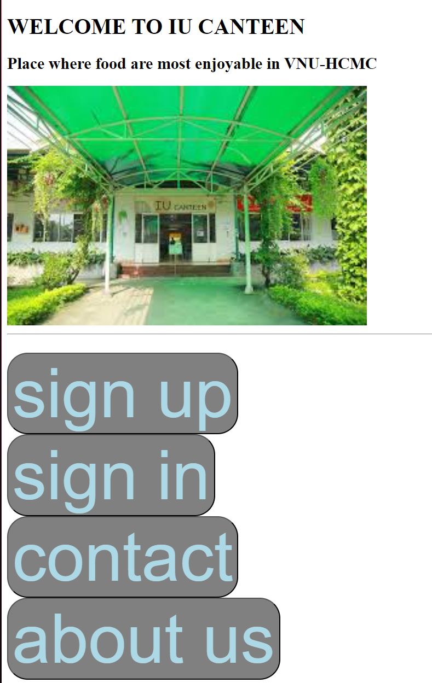

index page

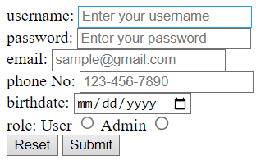

sign-up page

Distribute work for others members. Specifically:

* About UI(web page design) (deadline Sunday 20/10/2024):
  + Huy give the design pattern for the team to follow (the pattern about color, font, etc)
  + Đức make the welcome, sign-in, sign-up page
  + Phát make cart and order page
  + Huy make menu page for user and food modify page for admin
* About report (Tuesday 15/10/2024): Huy and Phát continue to work on the report for phase 2
  + Huy works on Gantt chart and timeline
  + Phát works on further description and working methods.